**DCMS**

**FUNCTION SPECIFICATION DOCUMENT**

**Version 0.1**

**Shanghai Huateng Software Systems Co., Ltd.**

Sep. 2018

**Change History**

|  |  |  |  |
| --- | --- | --- | --- |
| **Release** | **Date** | **Author** | **Reason for Change** |
| 0.1 | 2018-9-28 | Mindy Yao  Celine Xiang | Initial |
| 0.2 | 2018-12-3 | Gaoli | Update |
| 0.3 | 2018-12-21 | Gaoli | Update |
| 0．4 | 2019-01-28 | Gaoli | Update |
| 0．5 | 2019-03-13 | Gaoli  Lijun | Update |

**Approval & Sign-off**

This document has been issued to the following persons for approval and sign-off

|  |  |  |
| --- | --- | --- |
| **Date** | **Role** | **Name** |
|  |  |  |
|  |  |  |
|  |  |  |

# Index

Index 4

1. Introduction 6

2. Basic Specification 6

2.1. Acronyms, Abbreviations and Terms 6

3. Process Flow 6

3.1.1. Payment Request(Merchant) 6

3.1.2. Payment Status Enquiry(Merchant) 7

3.1.3. Transaction Cancellation (Merchant) 8

3.1.4. Channel Fee Billing (MQ) 8

3.1.5. Merchant Account Enquiry (MQ) 9

3.1.6. Daily Reconciliation& RMS Interface 10

3.1.7. Merchant Report Sending 11

3.1.8. AMLO Report File (only for BKH) 12

4. Page Operation Rule 12

4.1. Home Page 12

4.1.1. Login Information 12

4.2. System Management 12

4.2.1. Country/Institution Setup 12

4.2.2. Country/Institution Approval 13

4.2.3. Country/Institution Query 13

4.2.4. Holiday Management 13

4.2.5. Holiday Approval 13

4.2.6. Scheduled Job 13

4.3. User Management 14

4.3.1. Role Setup 14

4.3.2. Role Approval 14

4.3.3. Role Query 14

4.3.4. User Setup 15

4.3.5. User Approval 15

4.3.6. User Query 15

4.4. Merchant Management 15

4.4.1. Merchant Setup 15

4.4.1.1. New (add new merchant country/institution: THHBAP/IDHBAP) 15

4.4.2. Merchant Approval 17

4.4.3. Certificate Setup 17

4.4.4. Certificate Approval 18

4.4.5. Certificate Query 18

4.4.6. Bind Certificate 18

4.4.7. Bind Certificate Approval 18

4.4.8. Aggregator Setup 18

4.4.9. Aggregator Approval 18

4.4.10. Charge Rate Setup 18

4.4.11. Charge Rate Approval 19

4.4.12. Merchant Query 19

4.4.13. Certificate Query 19

4.4.14. Aggregator Query 19

4.4.15. Charge Rate Query 19

4.5. Transaction Management 19

4.5.1. Transaction Query 19

4.5.2. Login History Query 20

4.5.3. Operation Log Query 20

4.6. EOD Management 20

4.6.1. Report Query 20

4.6.2. Report Manual Generation 21

4.6.3. Reconciliation Failure Query 21

4.6.4. Manual Charge 21

4.6.5. Manual Charge Approval 22

4.6.6. Manual Payment Inward Setup(THHBAP) 22

4.6.7. Manual Payment Inward Approval(THHBAP) 22

# Introduction

This document elaborates the functional flow of DCMS especially on payment process, the interaction between merchants, HSBC DCMS and aggregators for users to have a quick grasp of the system function.

# Basic Specification

## Acronyms, Abbreviations and Terms

DCMS: Digital Collection Management System.

# Process Flow

### Payment Request (Merchant)



Explanation of Workflow:

1. Customers submit payment on merchant’s website.
2. Merchant make payment request to DTP, who will run API message checking, after checking pass, forward the request to DCMS.
3. DCMS will reply with Aggregator Redirect Payment page link.
4. Consumer will be directed to Aggregator Payment Page to finish payment.
5. Once payment is done, aggregator will notify DCMS via API call about the payment result, DCMS will forward the payment result to proxy server, who will forward the notification back to the corresponding merchant.  
   The payment notification URL is maintained by the merchant and it needs to be provided as one of the parameters in the Payment Redirect API.
6. API specification: DCMS—2c2p(Thailand)
   1. 
7. API specification: DCMS—DOKU(Indonesia) unzip open with Chrome:
   1. 

### Payment Status Enquiry(Merchant)



Explanation of Workflow:

1. If merchant didn’t receive the payment result information, merchant can launch payment status enquiry API call to DTP, who will do rules checking to the API message, if passed, forward payment status checking to DCMS, DCMS will make payment enquiry API call to Aggregator.
2. Aggregator will respond the payment enquiry with the transaction payment status information, the response message will be forwarded back to merchant.

### Transaction Cancellation (Merchant)



Explanation of Workflow(only applicable for DOKU):

1. Merchant can launch void/refund/cancellation API call to cancel or refund a transaction. DTP will do message format checking, if pass, forward the message to DCMS, DCMS will form void/refund/cancellation API message to aggregator.
2. Aggregator will reply the processing result back to DCMS, then the void/refund/cancellation result message is forwarded back to merchant.

### Channel Fee Billing (MQ)



**Illustration:**

1. DCMS sends to HUB ‘Channel fee billing message’ on working days so that HUB could charge channel fee from merchant account.
2. Acquiring fee is pre-deducted by Aggregator so DCMS will not send HUB acquiring fee information for Indonesia and Thailand Branch.
3. HUB will make charges from merchant account,
   1. If success, end of process for Indonesia. For Thailand, DCMS will send ‘VAT billing message’ to HUB immediately after Channel Fee posting .
   2. If failed, manual charge from DCMS need to be triggered to inform HUB to charge again. The failed channel fee billing messages and VAT billing messages can be found in the menu of ‘manual charging’. After approving the billing messages, DCMS will send the channel fee billing message or VAT billing messages to HUB again.
4. Exchange Message format between HUB and DCMS for channel fee billing :
   1.  

### Merchant Account Enquiry (MQ)



**Illustration:**

1. During Merchant Setup or merchant account modification, upon online request by clicking search(Settlement Account & Charge Settlement Account), DCMS will send ‘Merchant Account Enquiry’ to HUB using MQ and get merchant account information from HUB to verify the account and ensure inputted account can be operated.

Account Status, Restriction.

|  |  |
| --- | --- |
| Account Status | Restriction Code |
| 1. Active | 1. Normal |
| 2-Dormant | 2- No excess |
| 3- Unclaimed | 3-Manual entry inhibited |
| 4-Closing | 4- Balance blocked |
| 5-Closed | 5-No cheques |
|  | 6- No other balance |

If no account found in HUB, prompt error message ‘HUB account not found’; If Account Status is Active && Restriction Code is Normal or No excess then validation passes.

### Daily Reconciliation& RMS Interface

**Illustration:**

1. Aggregator generates ‘EOD Settlement file on working day, DCMS will retrieve the settlement file and do reconciliation with its own transaction records and update DCMS records according to the settlement file data if any discrepancy found.
   1. Aggregator generates merchant daily transaction report file, DCMS retrieve the file via SFTP:
   2. 
   3. DCMS retrieves the 2C2P recon file and do reconciliation with its own transaction records in DB and updates table mc_txn

|  |  |  |
| --- | --- | --- |
| **2C2P Recon File** | **MC_TXN** | **Remark** |
| INVOICE_NO | ORDERNO | refund-TXNID |
| BATCH_NO | BATCHNO |  |
| ORDER_DATE | TXNDATE |  |
| ORDER_TIME | TXNTIME |  |
| PAYMENT_DATE+PAYMENT_TIME | PAYMENTDATETIME |  |
| MERCHANT_ID | MERID |  |
| PAYMENT_TYPE | PAYTYPE |  |
| PAYMENT_CHANNEL | PMTCHAN |  |
| AMOUNT | TXNAMT |  |
| AMOUNT-PAYIN_AMOUNT | AGTFEE |  |
| CurrencyCode | TXNCRY |  |
| Approval_code | APRVCODE |  |
| ECI | ECI |  |
| TxnID | PAYMENTCODE |  |

* 1. DCMS retrieves the DOKU recon file and do reconciliation with its own transaction records in DB and updates table mc_txn_id:

|  |  |
| --- | --- |
| **DOKU Recon File** | **MC_TXN** |
| TRANSIDMERCHANT | ORDERNO |
| BATCH ID | BATCHNO |
| MERCHANT NAME | MERNM |
| TRANSACTION DATE | TXNDATE |
| PAYMENT CHANNEL NAME | PMTCHAN |
| CUSTOMER NAME | CUSTNM |
| PAYMENT CODE/CREDIT CARD | CARDNO |
| AMOUNT | TXNAMT |
| APPROVAL CODE | APPROVALCODE |
| FEE | AGTFEE |
| PAY OUT DATE | SETTDATE |
| TRANSACTION TYPE | PAYTYPE |

1. Aggregator pushes PGW and 123 payment inwards to HUB via BAHTNET (For Thiland) and pushes one single aggregated settlement amount via RTGS (For Indonesia) for each merchant.
2. HUB will then based on the narrative of the payment inwards and send CTI message to DCMS if applicable , DCMS will do reconciliation for each merchant on net amount calculated in the settlement file against the HUB settlement amount



* 1. If reconciliation is successful :
     1. DCMS generates Merchant Daily settlement summary report.
     2. DCMS generates RMS data file according to RMS requirement and send to RMS. RMS data file specification:



* 1. If reconciliation is failed, system generate ‘Recon Exception Report’ for bank staff to follow up.
  2. TH Reconciliation logic and Excepted results:

|  |  |  |  |  |
| --- | --- | --- | --- | --- |
| No. | Aggregate Recon File total amount | Payment Inward Amount (CTI) | Recon Balance | Excepted Result |
| 1 | aggregate total amount=0 | no HUB CTI msg | Y | Settlement Summary |
| 2 | aggregate total amount=0 | HUB settled amount>0 | N | Exception Report |
| 3 | no reconciliation file | no HUB CTI msg | / | / |
| 4 | no reconciliation file | HUB settled amount>0 | N | Exception Report |
| 5 | BAHTNET Remittance Fee>aggregate total amount>0 | no HUB CTI msg | N | Exception Report |
| 6 | aggregate total amount>BAHTNET Remittance Fee | aggregate total amount -BAHTNET Remittance Fee= HUB settled amount | Y | Settlement Summary |
| 7 | aggregate total amount>BAHTNET Remittance Fee | aggregate total amount -BAHTNET Remittance Fee≠ HUB settled amount | N | Exception Report |

* 1. ID Reconciliation logic and Excepted results:

|  |  |  |  |  |
| --- | --- | --- | --- | --- |
| No. | Aggregate Recon File total amount | Payment Inward Amount (CTI) | Recon Balance | Excepted Result |
| 1 | aggregate total amount=0 | no HUB CTI msg | Y | Settlement Summary |
| 2 | aggregate total amount=0 | HUB settled amount>0 | N | Exception Report |
| 3 | no reconciliation file | no HUB CTI msg | / | / |
| 4 | no reconciliation file | HUB settled amount>0 | N | Exception Report |
| 5 | aggregate total amount>0 | no HUB CTI msg | N | Exception Report |
| 6 | aggregate total amount>0 | aggregate total amount = HUB settled amount | Y | Settlement Summary |
| 7 | aggregate total amount>0 | aggregate total amount ≠ HUB settled amount | N | Exception Report |

### Merchant Report Sending

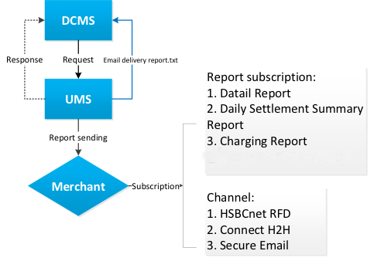

**Illustration:**

1. If merchants subscribed reports through listed channels, DCMS will send the generated reports to UMS as well as any attachment or email content, UMS will execute the sending of the reports according to report subscription setting Merchant Setup.
2. UMS will respond with error message if API message check failed or reply processing successfully if no error.
3. UMS will send ‘Email Delivery Exception Message’ to DCMS if email sending is failed.
4. DCMS will generate Email Recon Report, contains the report details what send failed via Secure Email.
5. Exchange message format specification between DCMS—UMS:



# Page Operation Rule

## Home Page

## Login Information

**Function description:**

1. When user login, DCMS will forward the user information to SSO login system, and SSO will send the user role information back to DCMS. DCMS will verify whether the user can log in successfully according to the role information
2. After logged into the system, check the current login country/institution, user can click on right top buttons to switch institution/ log out of system.
3. Check To-do-List and click ‘Handle’ to go to the handling page directly.

## System Management

## Country/Institution Setup

**Function description:**

1. To view all the Institutions configured in the system.
2. To modify institution information: country/institution name and it’s time zone by clicking ‘Amend’.
3. All the changes will need to be approved by upper level user to take effect.

## Country/Institution Approval

**Function description:**

1. To approve the Country/Institution setup or modification.
2. Approval can only be performed by supervisor level user.

## Country/Institution Query

**Function description:**

1. To view any country/institution configured in the system and each creation, modification history.
2. Query by simply clicking ‘Search’ to view all the institutions or input filtering conditions: country/institution code or country/institution name.

## Holiday Management

**Function description:**

1. To view the holiday setting in the calendar from current year to next 9 years.
2. To mark any future date as holiday or working day.
3. Single click to set the weekday as holiday or weekend as working day, click again to restore.
4. All the changes will need upper level user’s approval to take effect.

## Holiday Approval

**Function description:**

1. To view the holiday and working day changes application to approve or reject.

## Scheduled Job

**Function description:**

1. To view the jobs configured in the system and manually execute the job.
2. Reconciliation Job(2C2P&DOKU): Manually execute the job to trigger re-capturing EOD Transaction Details File from Aggregator.
3. AMLO Job: Manually execute to generate file to send to AMLO.
4. Email Reconciliation Job: DCMS depends to UMS to send subscribed reports via different channel, as shown in Merchant Report Sending, if the sending is failed, UMS will send DCMS notification, this job is to convert the failed email notification into excel file for user to download and read.
   1. Excel can be downloaded by accessing: EOD Management🡪Report Query🡪

Email Recon Report: 

1. Hub Recon Job: Manually execute to trigger reconciliation between HUB sent CTI Reporting(Merchant Daily settled whole amount) and Merchant detailed transaction calculated whole amount, if reconciliation fails, system generates Recon Exception Report:
2. DetailReportGeneJob: To generate the detail report at the ‘detail report generate time‘, and send to merchant via UMS
3. DetailExceptionReportGeneJob: To generate ‘Unsettled Transaction Detail Report’, execute once a day
4. SendBillingMqThJob: To send channel fee billing to HUB via MQ on workday, and generate charge report after receiving the reply from HUB
5. RMS Job: to generate RMS data file according to RMS requirement and send to RMS, one file per merchant, only applicable for recon success’ merchant.
6. HolidayMngJOB: to receive files from HUB and set holidays.
7. Schedule job run time:

|  |  |  |
| --- | --- | --- |
| **Job Name** | **TH-Job Time(GMT +7)** | **ID-Job Time(GMT +7)** |
| Email Reconciliation Job | 6:30 | 6:30 |
| Aggregate Reconciliation Job | 15:00 | 17:00 |
| SendBillingMqJob | 15:30 | 17:30 |
| Hub Recon Job | 16:00 | 18:00 |
| RMS | 16:30 | 18:30 |
| HolidayMngJOB | *:10 | *:10 |
| DetailReportGeneJob | per minute | per minute |
| DetailExceptionReportGeneJob | Per hour | Per hour |

## User Management

## Role Setup

**Function description:**

1. To create or modify system roles with different level of system permission. The created roles can be configured to users so that users with same role assigned have the same permission to access system pages or modules.
2. Newly created role will remain ‘pending to be approved’ until being approved by higher level user.

## Role Approval

**Function description:**

1. Upper level user can approve or reject role changes or newly set roles.

## Role Query

**Function description:**

1. To view the role permission level: pages and modules the role has access to.
2. To view all the users that have been assigned to this role.

## User Setup

**Function Description:**

1. Search all the users in the system or search by filtering conditions: user ID, user name.
2. View user’s information and assigned role information.
3. Add new users, assign roles, modify current user information or delete users, the changes can only take effect after supervisor level user’s approval.

## User Approval

**Function Description:**

1. To approve or reject user setup or modification changes.

## User Query

**Function Description:**

1. To search all the users in the system or search by filtering conditions: user ID, user name.
2. To view user ID status, last login time, belonging institution, user configuration details such as assigned role, email, etc.

## Merchant Management

## Merchant Setup

**Function Description**

1. To View and search all the merchants in the system.
2. Add new merchants and modify information of current merchants.
3. All the changes can be effective only after upper level user’s approval.

## New (add new merchant country/institution: THHBAP/IDHBAP)

1. Click ‘Merchant Management’🡪Merchant Setup, to access following page:

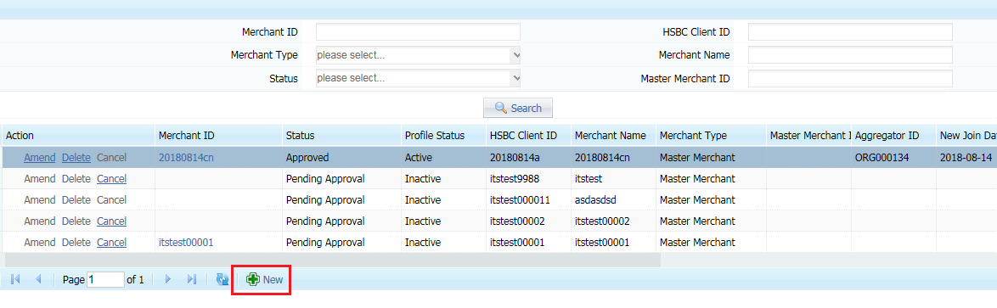

1. Click ‘New’ to add new merchant into system: input all the required information.
2. Click Amend to modify merchant information, information modification will only take effect after upper level user approval.
3. click ‘new’ to access details input page as following(* sign means must input(not null)):
4. Following is the details input page of THHBAP institution, other country/ institution page elements may vary:

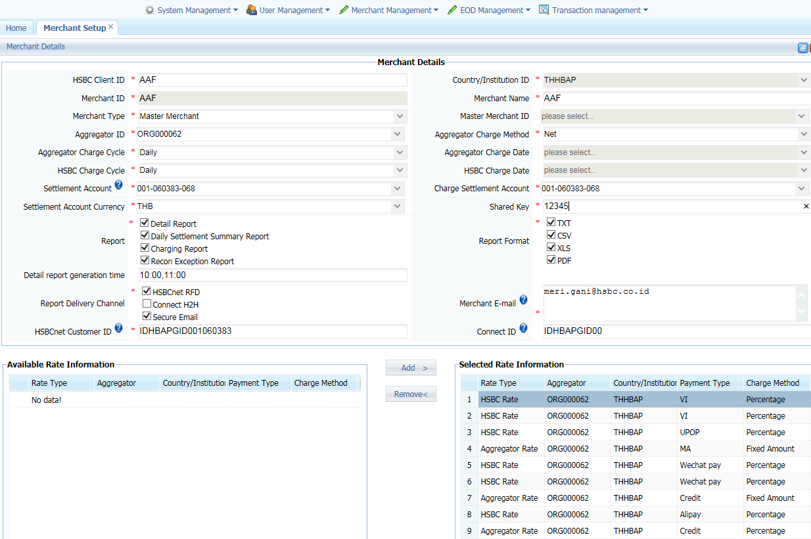

Page elements and input rules:

|  |  |
| --- | --- |
| Elements | Rules Validation |
| HSBC Client ID* | 1.maximum 13 characters  2.number and alphabet only |
| Country/Institution ID | prefilled |
| Merchant ID* | 1.TH maximum 15 characters  2.ID Maximum 8 characters  3. number and alphabet only |
| Merchant Name* | 1.maximum 512 characters  2.local languages are allowed |
| Merchant Type* | 1.choose from dropdown list  2.Master Merchant/Sub Merchant |
| Master Merchant ID | 1. it's mandatory if it’s sub merchant  2. choose the master merchant id from dropdown list |
| Aggregator ID* | 1.default value(2C2P/DOKU) |
| Aggregator Charge Method* | 1.choose from the dropdown list  2.only support 'Net' now |
| Aggregator Charge Cycle* | 1.choose from dropdown list  2. Daily/Monthly |
| Settlement Account* | 12 digits, by inputting settlement account and click search, system will send ‘settlement account’ to HUB to query account information |
| Charge Settlement Account* | 12 digits, by inputting account and click search, system will send ‘settlement account’ to HUB to query account information |
| Settlement Account Currency* | choose the local currency from drop down list |
| Shared Key | Mandatory field for user to input. Shared Key is an agreed serial code between DCMS and Aggregator for transaction signature key. |
| Report* | select at least one |
| Report Format* | select at least one |
| Report Delivery Channel* | select at least one |
| Detail report generation time | Mandatory if detail report is chosen  (format:HH:mm,HH:mm) |
| HSBCnet Customer ID | Mandatory if Channel HSBCnet RFD and Connect H2H are chosen; 12-18 characters, number and alphabet only |
| Connect ID | Mandatory if Channel Connect H2H is chosen, exact 11 characters, number and alphabet only |
| Merchant E-mail | Mandatory if Channel Secure Email is chosen; multiple mailboxes are separated by semi-colon |
| Available Rate Information | select the charge rate |

1. After finished all the information input, click save on the bottom of the page, the status will remain ‘pending approval’.
2. User can also modify merchant information by clicking ‘Amend’, modification will take effect after upper level user approve.

## Merchant Approval

**Function Description:**

1. To approve or reject Merchant setup or modification changes.

## Certificate Setup

**Function Description:**

1. To View and search all the certificates in the system.
2. Add new certificates and modify information of current certificates.
3. All the changes can be effective only after upper level user’s approval.

**Validating rules upon uploading .cer file:**

1. API Client ID - Maximum 60 characters
2. Certificate Version - Must be 4 unique digits
3. Effective Date - Select from calendar, must be a future date.
4. Effective Time - Select from the timetable.
5. Header Info – Encrypted string, it’s used when pushing notification to merchants
6. Upload File - Choose a file which should be issued by Certificate Authority, and the file format must be *.cer

## Certificate Approval

**Function Description:**

1. To approve or reject Certificate setup or modification changes.

## Certificate Query

**Function Description:**

1. To approve or reject Certificate setup or modification changes.

## Bind Certificate

**Function Description:**

1. After successfully uploaded certificate and approved, user can bind the Merchant with its certificate. Binding will take effect after different user’s approval.
2. Certificate is used between DCMS and corresponding Merchant for payment notification API message encryption (DCMS notify merchants about payment result).

## Bind Certificate Approval

**Function Description:**

1. After certificate binding submission, switch to different user to approve or reject the certificate binding.

## Aggregator Setup

**Function Description**

1. To View and search all the aggregators in the system.
2. Add new aggregators and modify information of current aggregators such as modify payment type.
3. Newly added Aggregator or Aggregator modification will remain ‘pending approval’ until senior level user approve.

## Aggregator Approval

**Function Description:**

1. Switch to senior user ID to approve or reject aggregator setup or modification.

## Charge Rate Setup

**Function Description**

1. To View and search all the rates configured in the system.
2. Add new rates and modify current rates.
3. All the changes can be effective only after upper level user’s approval.

## Charge Rate Approval

**Function Description**

1. Switch to senior user ID to approve or reject charge rate setup or modification.

## Merchant Query

**Function Description**

1. To search and view all the merchants configured in the system.
2. Download the search result into file.

## Certificate Query

1. To search and view all the certificates configured in the system.

## Aggregator Query

1. To search and view all the aggregators configured in the system.

## Charge Rate Query

1. To search and view all the rates configured in the system.

## Transaction Management

## Transaction Query

**Function Description**

1. To search and view all the transaction records such as transaction amount, charge amount, transaction status, etc.
2. Download search result into excel file.
3. ‘Transaction date from’ and ‘transaction date to’ default value: system date.

## Login History Query

1. To search and view all the user login history in the system.
2. Download search result into excel file.

## Operation Log Query

1. To search and view all the user login records in the system.
2. Download search result into excel file.

## EOD Management

## Report Query

**Function Description**

1. To search and view all the reports generated in the system.
2. Click report name to download the report into computer.
3. Report Name: **Details Report**
   1. 
   2. The report displays the merchant’s transaction records from defined start and end date. These transactions contain success, closed and void, except pending transactions.
4. Report Name: **Daily Settlement Summary Report**
   1. 
   2. The report displays daily settlement summary and daily transaction record details, daily transaction record details are the same format with ‘Details Report’.
5. Report Name: **Charging Report**

* 1. 
  2. The report displays charges of defined date range transactions depending on daily or monthly charge cycle.

1. Report Name: **Recon Exception Report**
   1. 
   2. System generates Recon Exception Report if reconciliation between HUB settlement and aggregator sent transaction details fails. This is the internal report for staff.
2. Report Name: **Mobile Collection Customer Profile Report**
   1. 
   2. The report displays all the merchants configured in the system and all the charging rate configured in the system, just contains the ‘approved’ merchants.
3. Report Name: **Certificate Expiry Report**
   1. 
   2. The report displays certificates that have been expired or to be expired within a month, the future expiration date index can be configured.
4. Report Name: **Email Recon Report**
   1. 
   2. The Mobile Collection Email Delivery Recon Report displays email-sending failure records sent by UMS.
5. Report Name: **Unsettled Transaction Detail Report**

10.1 

10.2 The report displays all ‘success’ but ‘unsettled’ transactions made four days ago.

## Report Manual Generation

1. To manually generate reports and go back to ‘report query’ to download.

## Reconciliation Failure Query

**Function Description**

1. To search and view all the reconciliation failure records in the system.

## Manual Charge

**Function Description**

1. To search and view all the failed charging records in the system and resubmit charge.
2. Select the failed records and click ‘charge’ to finish the operation.
3. Submitted charge will remain ‘pending approval’ until being reviewed by upper level user.

## Manual Charge Approval

**Function Description**

1. Switch to upper level user account, to approve or reject the submitted charge record.

## Manual Payment Inward Setup

**Function Description**

1. To manually input a transferred money record if system fails to display under exceptional case.
2. Submitted payment information will remain ‘pending approval’ until being approved by upper level user.

## Manual Payment Inward Approval

**Function Description**

1. Switch to upper level user account to approve or reject the submitted transaction record.

🡨-------------------------------This is the end of the Doc-------------------------------->